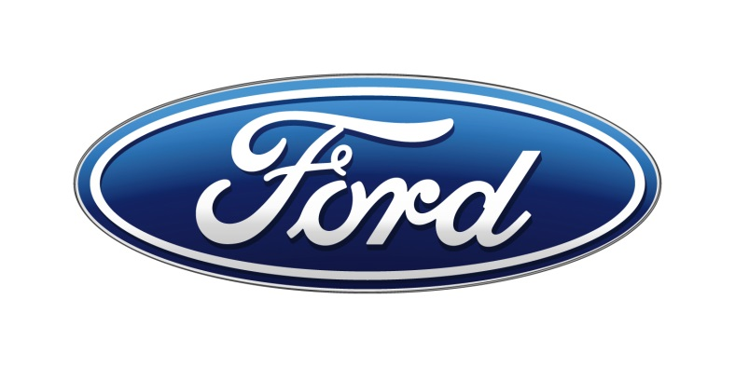

**Ford SYNC+ App Store**

**Dynamic WhiteList**

**Request for Quotation**

**Version 1.0**

**04/12/2022**

Printed Copies are Uncontrolled

FORD MOTOR COMPANY

CONFIDENTIAL

**The information contained**

**in this document is**

**Proprietary to Ford Motor Company.**

**Disclosure or distribution to unauthorized persons is strictly prohibited.**

**Copyright, Ó 2016 Ford Motor Company**

**Confidential and Proprietary – Ford Motor Company**

This document contains information developed and accumulated by and for FORD MOTOR COMPANY. As such, it is a proprietary document, which, if disseminated to unauthorized persons, would provide others with restricted information, data, or procedures not otherwise available, exposing the FORD MOTOR COMPANY to potential harm.

Employees and suppliers having custody of this specification or authorized to use it must be cognizant of its proprietary nature and ensure that the information herein is not made available to unauthorized persons.

FORD MOTOR COMPANY reserves the right to protect this work as an unpublished copyrighted work in the event of an inadvertent or deliberate unauthorized publication. FORD MOTOR COMPANY also reserves its rights under copyright laws to protect this work as a published work.

This document or portions thereof shall not be distributed outside FORD MOTOR COMPANY without prior written consent. Refer all questions concerning disclosure to the author(s) or to the Forward Model Radio Section, Ford Motor Company.

Table of Contents

1. Background and introduction 6

2. Objective and Scope 6

3. Product Requirement 6

4. Target offering scope and time plan 7

5. Legal requirement 7

6. System design and implementation 8

7. System Operation and SLA 9

8. Security and Data Protection 9

9. Project management 9

10. Company introduction 10

11. Response documents and RFQ Schedule 10

12. Contact Information 11

Version History

|  |  |  |  |
| --- | --- | --- | --- |
| Version | Author | Description | Release Date |
| 1.0 | Alex Ren | Initial version | 04/12/2022 |

# Background and introduction

Ford would like to introduce SYNC+ Appstore, Ford App Anywhere, namely the in-vehicle app store in China with open ecosystem and enriched content providing.

The in-vehicle apps could be updated anytime using Ford App Anywhere to enjoy the In-time and avant-garde experiences, to meet to meet the dynamic and differentiative customer in-vehicle wants.

Dynamic whitelist is a critical path so that Apps can be pushed from the cloud and can be download or update to vehicle. Dynamic whitelist SDK is what needs to be developed in this SOW.

This is a key reference document to introduce the Appstore dynamic whitelist requirements to help the partner to design and proposal the solutions accordingly.

# Objective and Scope

Since Ford provides Appstore feature, so Ford China is looking for a partner to deliver the Appstore platform Dynamic whitelist solution which enable:

* Ensure the applications downloaded through Appstore after feature going online can initiate and provide update service normally, and to ensure system security, avoid install APKs from unknown sources and being attacked.
* Two Security Protection module: [**Authorized Application Protection**] and [**Firewall**] needs to provide the ability to update security rules according to dynamic whitelist capability;
* Since Ford SYNC+3.0 will be switched to Android 11 form Android 9, authorization method of privacy permission will be different. [**Privacy Management**] module needs to be modified according to Android 11.

Partner is deemed to be industry experts and Ford would expect to be advised on industry best practices.

Ford will use this Request for Proposal (“RFP”) process to identify those suppliers and that also has the ability to become a long term partner for Ford.

# Product Requirement

Security Protection module

* [Authorized application protection] Add whitelist update requirement. The implementation method is that Appstore synchronizes the Path related information of online applications in Appstore through the API provided. The application is updated to the whitelist after obtaining the application certification.
* [Firewall] Add "whitelist update" requirement. The implementation method is that the Appstore synchronizes App package name related information of online applications in the App Store through the API provided and updates to the whitelist.

Privacy permission

* The authorization method of the Privacy Permission Page will changed from Switch button to the Authorization Level option, including Always Allow/Allow During Use/Ask Every Time/Do Not Allow;
* The Privacy Permission Page adds the icon display of the application downloaded through Appstore;
* The Modify Authorization Level dialog box will add to the Privacy Permission Page, which is used to modify the authorization level of the application's access rights (Always Allowed / Allowed During Use / Asked Every Time / Not Allowed);

# Target offering scope and time plan

Appstore is target to launch in Ford SYNC+3.0 vehicle programs leading by CDX707.

For system delivery, need to get dynamic whitelist develop done by mid of Jul to support end to end test.

# Legal requirement

**Please provide** kind suggestion that if related legal qualifications are needed for providing the in-vehicle Appstore in China, such as app audit standard, app release qualifications, etc.

Also **please provide** the related qualifications that your company has obtained.

# System design and implementation

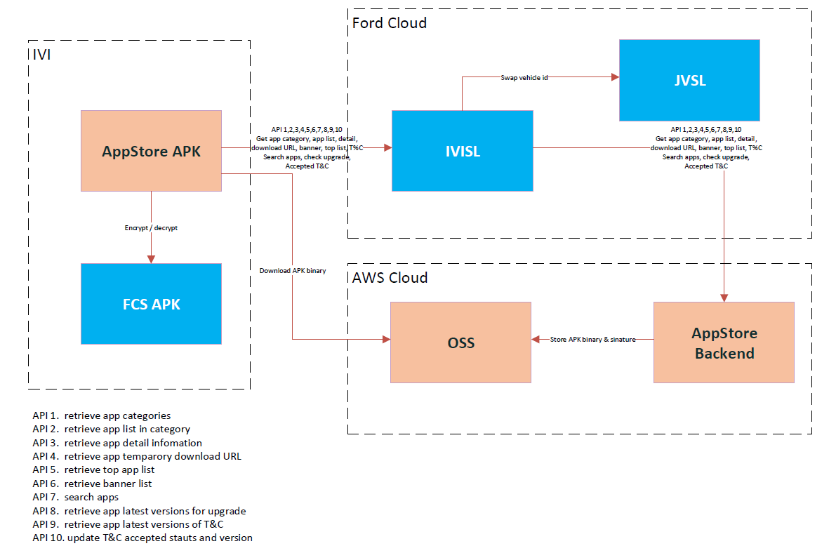

Supplier provide Appstore dynamic whitelist SDK to integrate with Ford Sync+ IVI SYNC+ 3.0, should be able to:

* Architecture Fit to Ford current Android OS;
* Provide methodology to install Ford system app / CPSP SW app / HW tier1 apps or call system installation plugin to install applications.
* Provide overall detailed dynamic whitelist architect diagram based on above AppStore system design

Delivery documents should include:

* Project plan
* MRD
* Architecture diagram
* Security solution
* System test plan
* System test report
* Operation methodology

# System Operation and SLA

Business continuity and sustainability highly rely on high level standard system operation. Certain application disaster recovery plan and recovery time objective are required to avoid below unexpected interruptions, but not limited to:

* Product failures
* Lost Data
* Sabotage
* Acts of nature
* …

**Service Level Agreement**

|  |  |
| --- | --- |
| **Metric** | **Service Level Agreement** |
| Total System Downtime | <=8 hours per month,<= 44 hours per year |
| Total Service Downtime | <=12 hours per month,<= 66 hours per year |
| Total Maintenance Window | <=8 hours per month,<= 48 hours per year |
| Total Abnormal Intervals | <=8 hours per month, <=44hours per year |
| Dynamic Whitelist Availability | >99.9% |

Please provide dynamic whitelist operation solution and manual operation process.

# Security and Data Protection

Security assurance is a key factor for product feasibility that, detailed security design, which mutually agreed solution is needed before system development and implementation, e.g. how to avoid security breaches; data transmission protocols should be up-to-date and secure; data leak prevention and backup.

Penetration testing for entire system would be executed during system implementation, which managed by either Ford or partner itself. Vulnerabilities found from test; the platform should fix in time according to its severity.

Please provide detailed Cyber security solution, Penetration testing plan;

# Project management

**Please provide** below required information:

* Detailed project delivery timeline,
* Architecture design
* Project/product organization chart,
* Governance model,
* Suggest development mode,
* Waterfall or agile developing method;
* Key delivery team location;
* Key delivery product/project/IT candidates resume

# Company introduction

**Please provide** company introduction, company shareholding structure, related OEM solution introduction, development team introduction,

# Response documents and RFQ Schedule

**Please provide** quotation for the product above. In this proposal, any product innovative thoughts/suggestions are welcome to share in the proposal.

Please consider variation of offer as a result of the number of audience recruited

In addition, please submit your corporate travel policy accompanying your proposal and quote.

|  |  |
| --- | --- |
| 2022.4.22 | SOW release from Ford |
| 2022.4.27 | SOW response with proposal and quotation |
| 2022.4.30 | Confirm supplier |
| 2022.05.15 | Start Date |
| 2022.07.15 | End Date |

# Contact Information

For questions and results submission regarding this SOW, you are welcome to contact:

Technical questions:

Name: Johnny Wang

Title: Deliver Manager, Experimental Manager

E-mail: [JWANG308@ford.com](mailto:JWANG308@ford.com)

Name: Alex Ren

Title: Experiential Product Delivery Lead

E-mail: [SREN6@ford.com](mailto:SREN6@ford.com)

Commercial questions:

Name:

Title:

E-mainl: